F110 -

Functionality
The Accounts Payable personnel will prepare a payment proposal in SAP, edit it and take out a hard copy print-out for approval and a sign-off. The hard copy would be forwarded to an employee who has authority to carry out a payment run. The person who carries out the Payment run in SAP shall compare the details approved on the hard copy with the edited proposal pending in SAP and on his satisfaction about these being identical, shall carry out a payment run in SAP.

The system will post documents recording debit of the Vendor and crediting the Bank sub-account.

Scenario
You want to print the checks according to the previously prepared payment proposal.

Requirements
Check lots are maintained in the system

Menu Path | Accounting → Treasury → Cash Management → Planning → Payment Program → F110 - Payment Proposal
Transaction Code | F110

1. Double Click F110 Payment Proposal:

Automatic Payment Transactions: Status

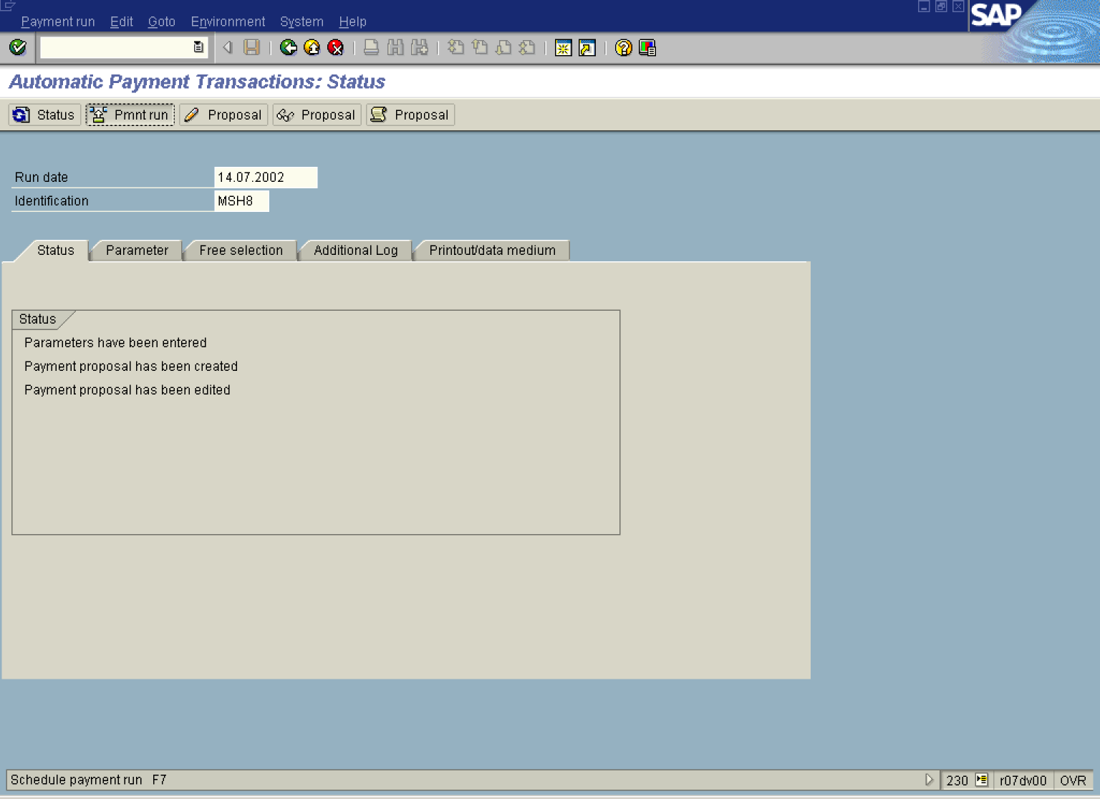

2. Update the following fields:

Field Name | Field Description | Values
Run date | The run date is used for identifying the parameters. It is the date on which the program is to be carried out as planned. However, a program run at an earlier or later date is also possible. | Example: 14.07.2002
Identification | You can use the additional identification to distinguish between several runs with the same reconciliation key date. You can freely define the identification. | Example: MSH8

 The payment proposal was already created (it includes the invoices to be paid). You need to now create the payment documents and perform postings to update GL accounts and sub ledgers (AP and AR).

3. Click Pmnt run Button to begin processing.

Schedule Payment

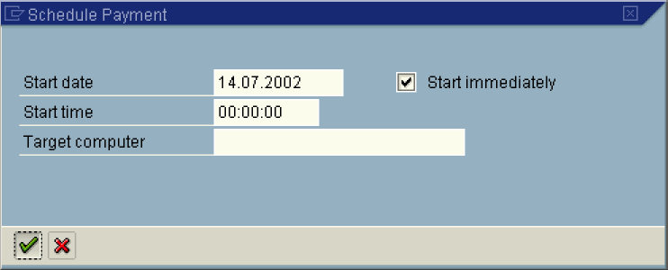

4. Mark radio button Start immediately and click Enter Button. The system will perform postings.

Automatic Payment Transactions: Status

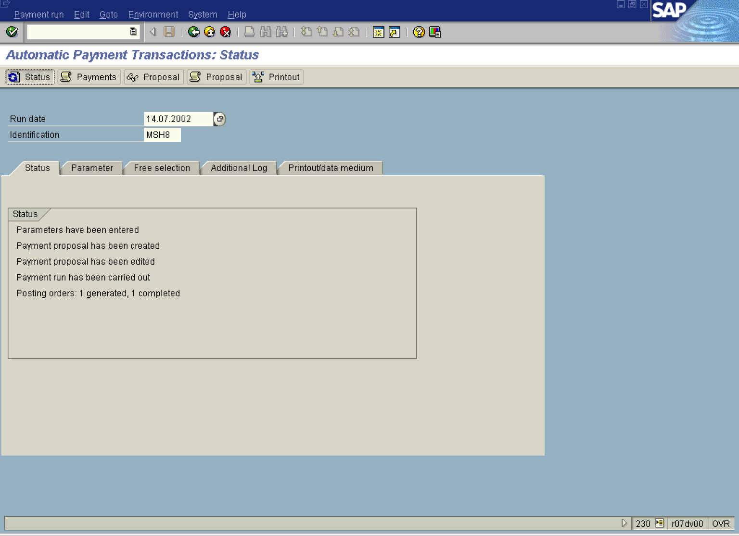

5. Click Status Button to refresh the screen.

Sometimes you need to press Status button several times, if there are lots of transactions to be processed.

6. The first phase (posting documents) is done. To display / print the list of payment document select from the menu path: EditPaymentsPayment list....

List Variant

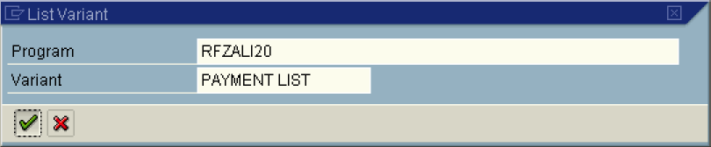

7. Select a variant Payment List and click Enter Button.

Payment list

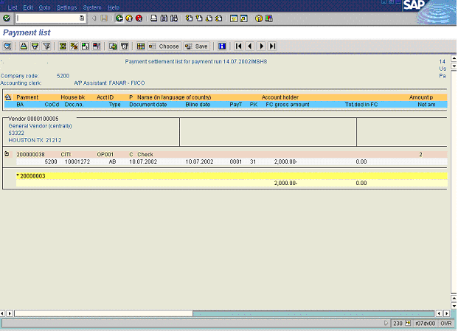

8. The system has displayed a list of documents included in the payment proposal. The list can be printed or stored as a local file.

9. Click Back .

SAP R/3

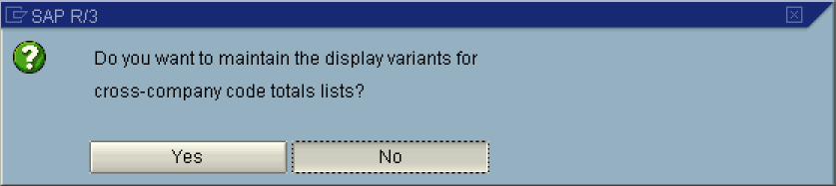

10. Click No Button 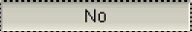.

Automatic Payment Transactions: Status

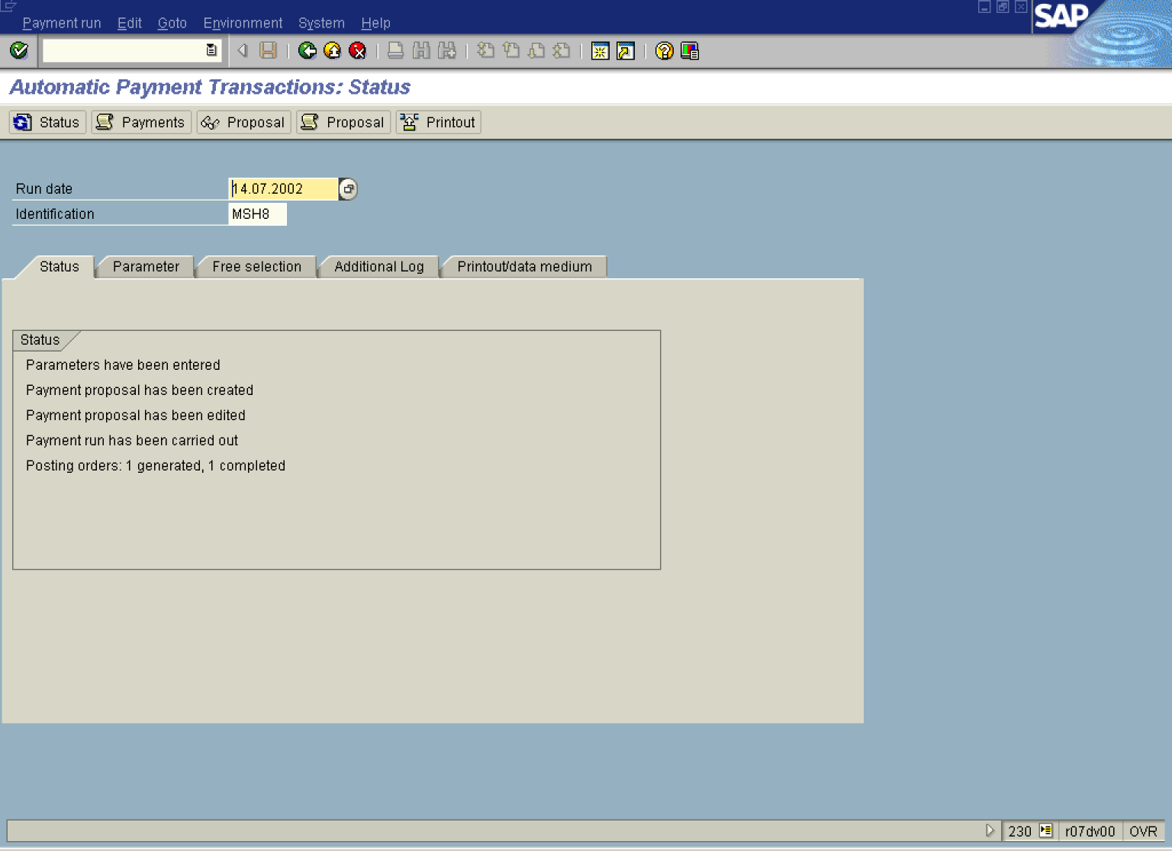

11. Now you can print the checks. First, click <tab button> Printout/data medium .

Automatic Payment Transactions: Printout and DME

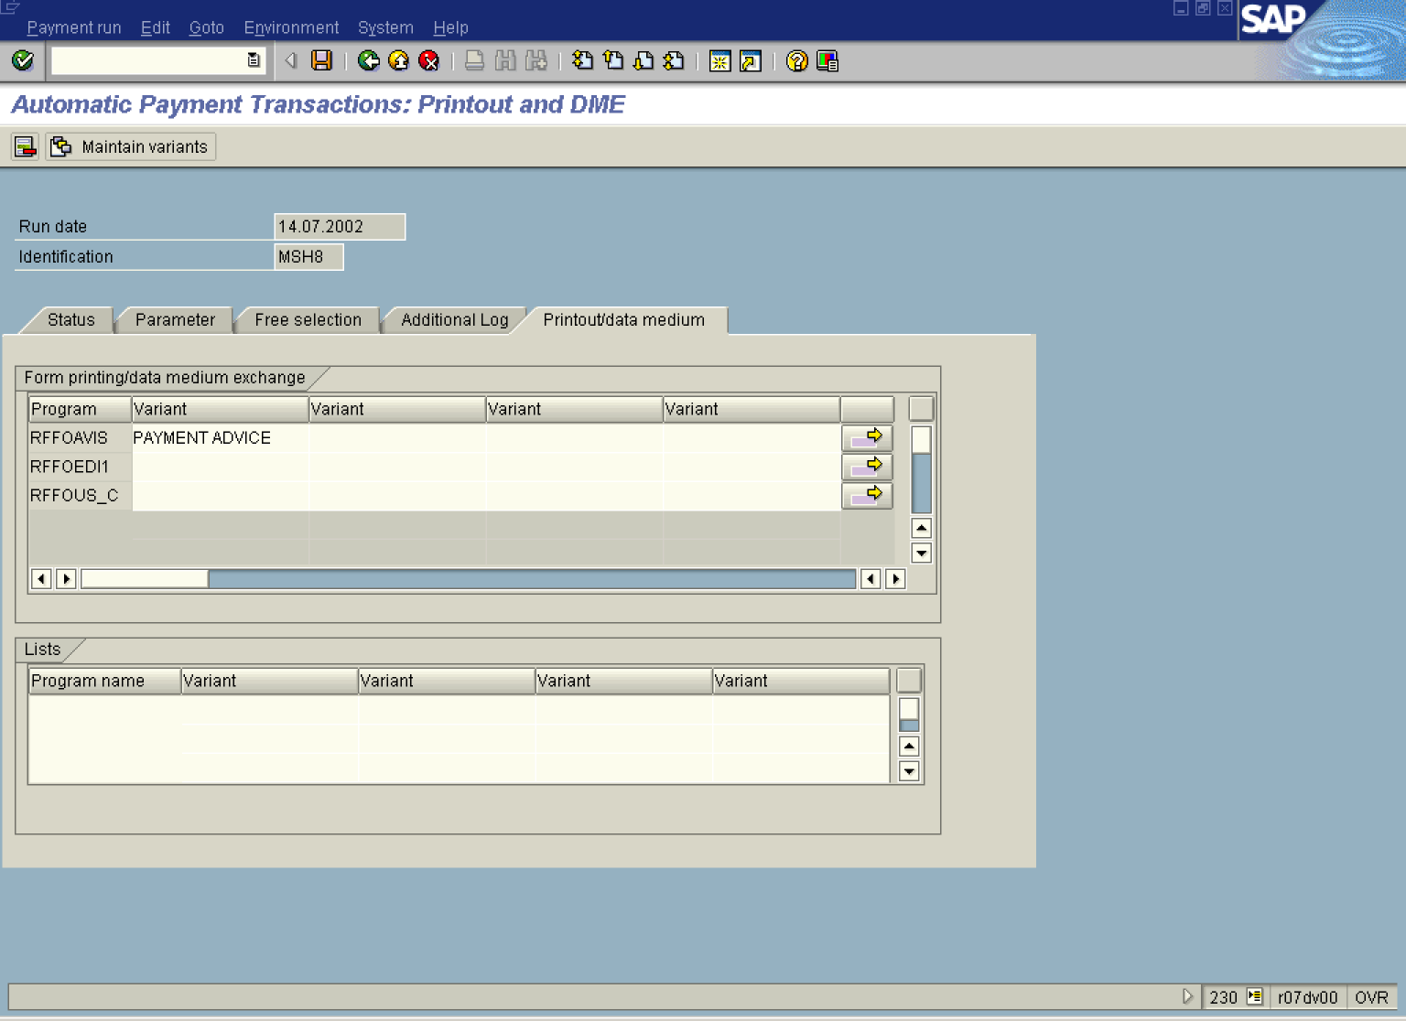

12. In the field Variant enter the variant’s name PAYMENT ADVICE, in the same line where’s the program RFFOAVIS

Tip: You can also search for the variant. Press [F4] or click the button in the Variant field

13. Next, in the field Variant enter the variant’s name CHECK, in the same line where’s the program RFFOUS_C:

Automatic Payment Transactions: Printout and DME

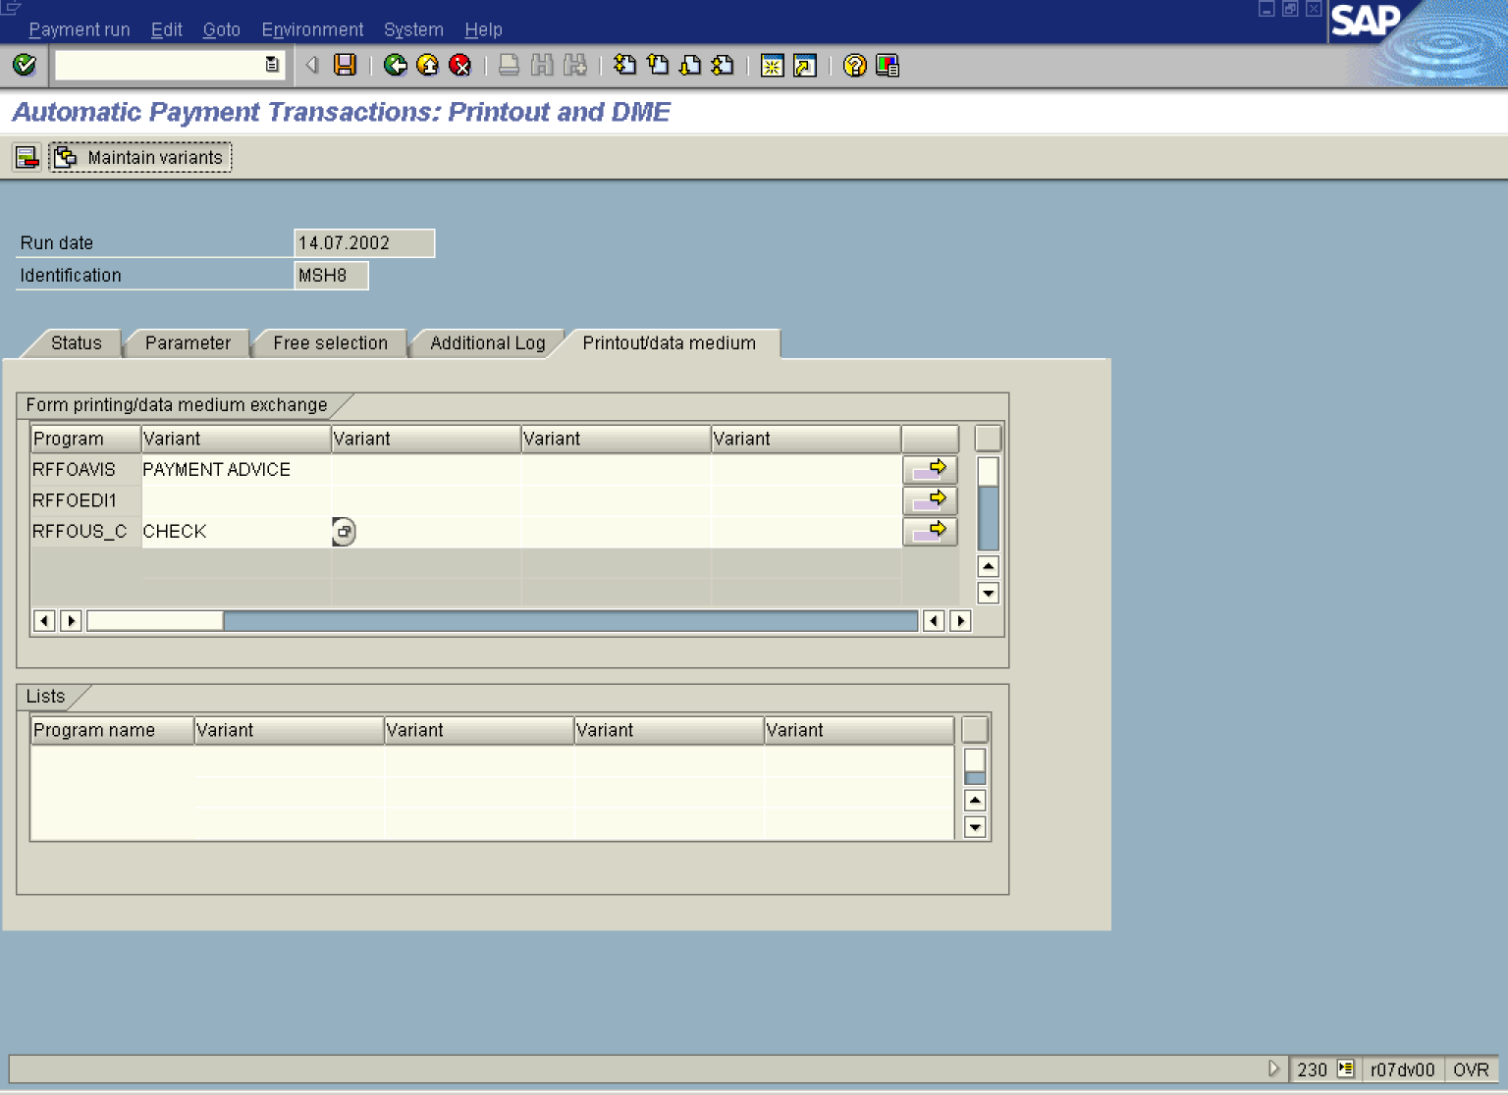

Sometimes you need to maintain the print variant. Keep the cursor in the field Variant (to select it for edition) and press the icon Maintain Variants . The system will allow you to change variant parameters.

14. Click Back n . The system will ask you to save the changes:

Exit editing

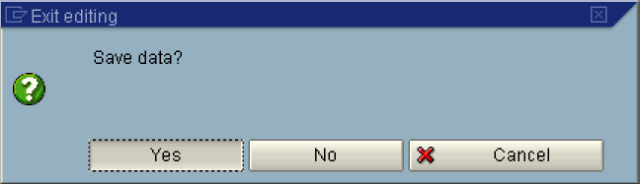

15. Click Yes Button .

Automatic Payment Transactions: Status

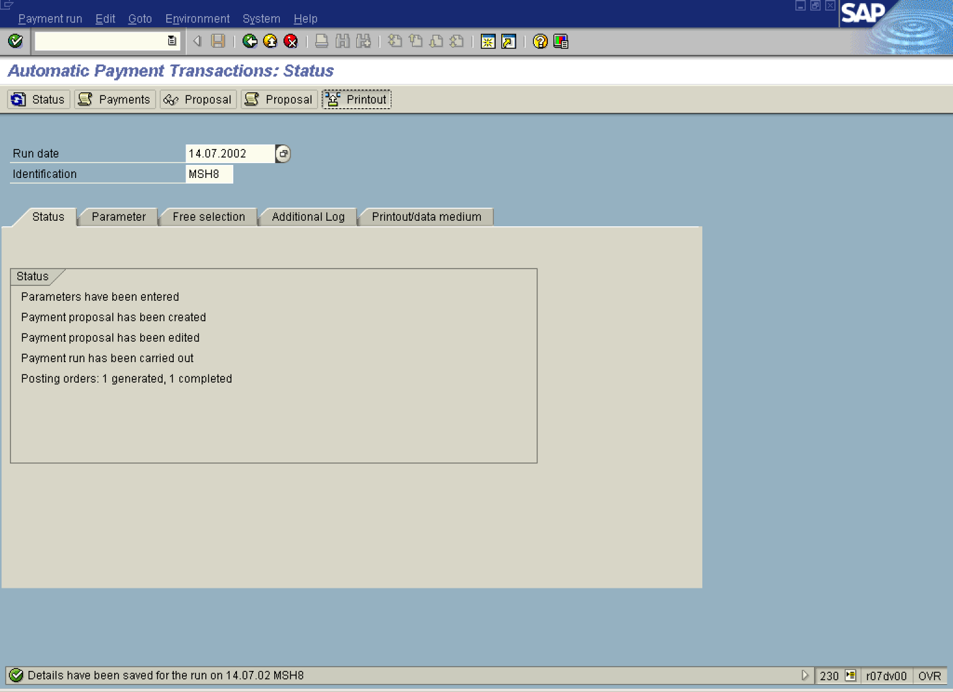

16. Once the variants were chosen, you can print the checks. Click Printout Button .

Schedule Print

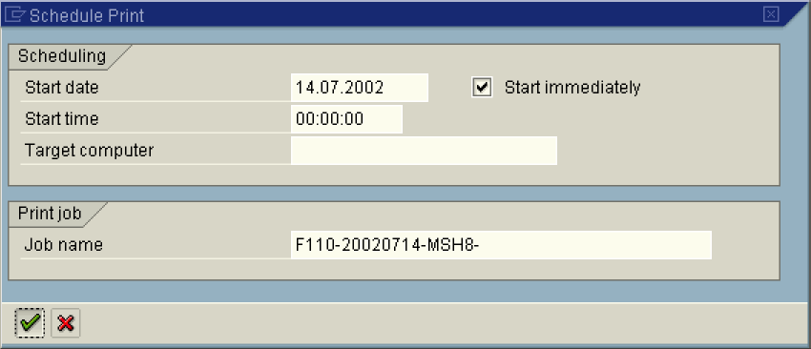

17. Mark Start immediately radio button and update the following fields:

Field Name | Description | Values
Job name | Job name for the print job | Example: F110-20020714-MSH8

18. Click Enter Button.

Automatic Payment Transactions: Status

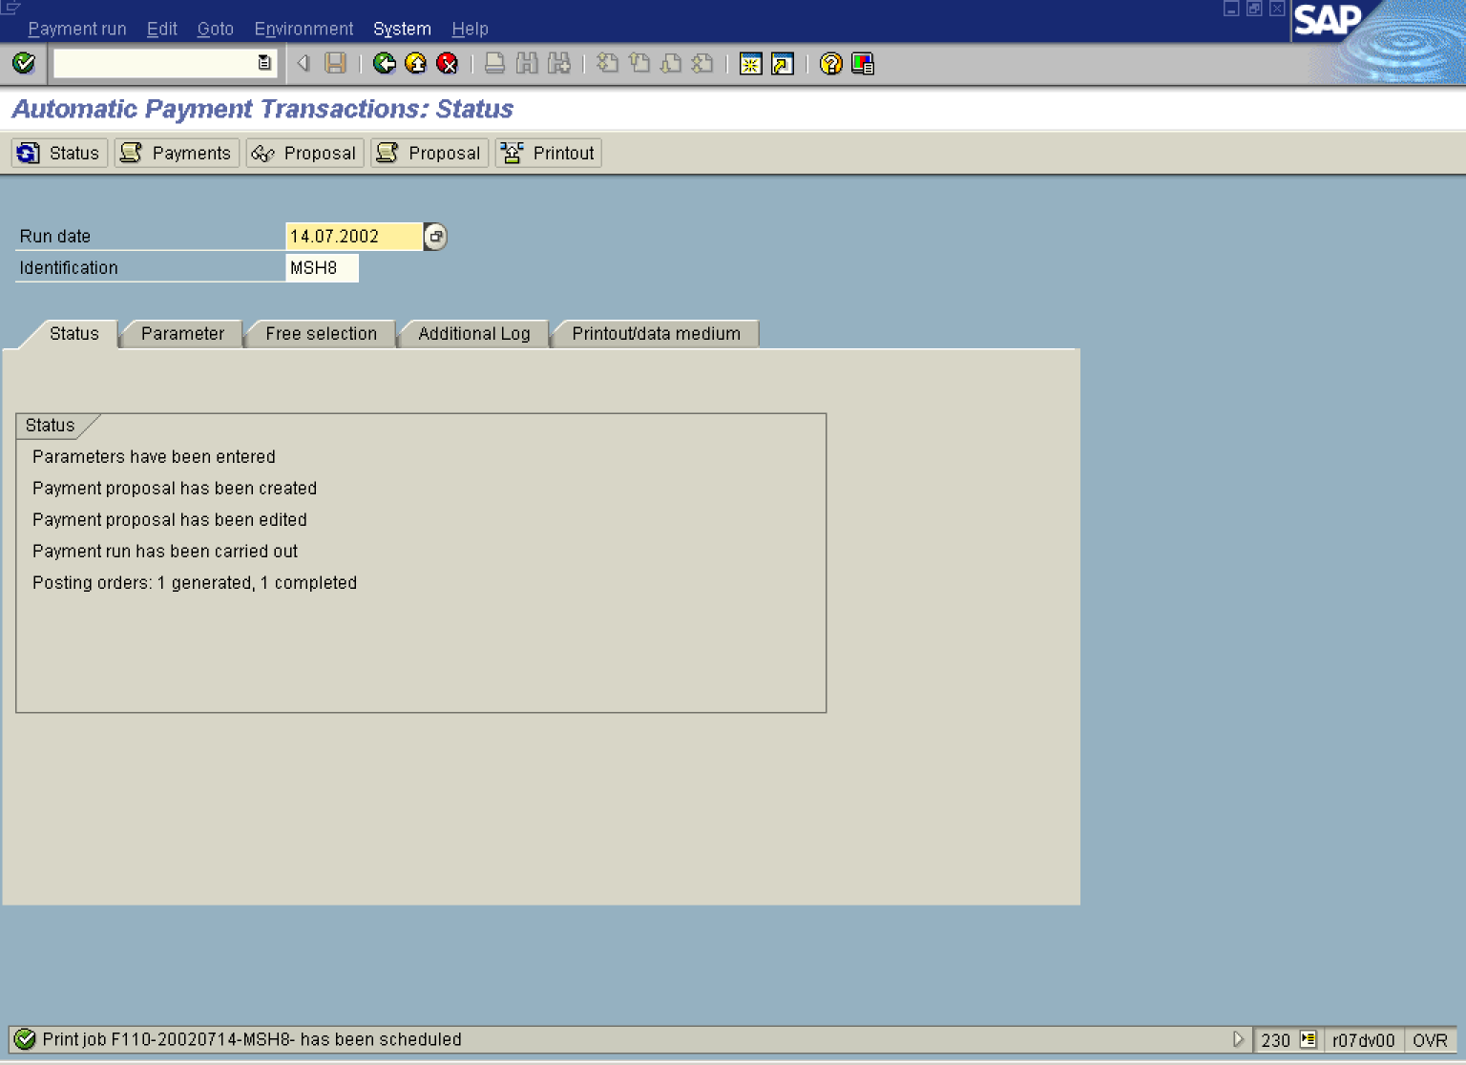

 The print job was created and saved in the spool. The system created three print jobs:
- payment summary
- payment advices,
- checks

19. To print the checks, select from the menu path: SystemServicesOwn spool requests. (Transaction SP02)

Output Controller: List of Spool Requests

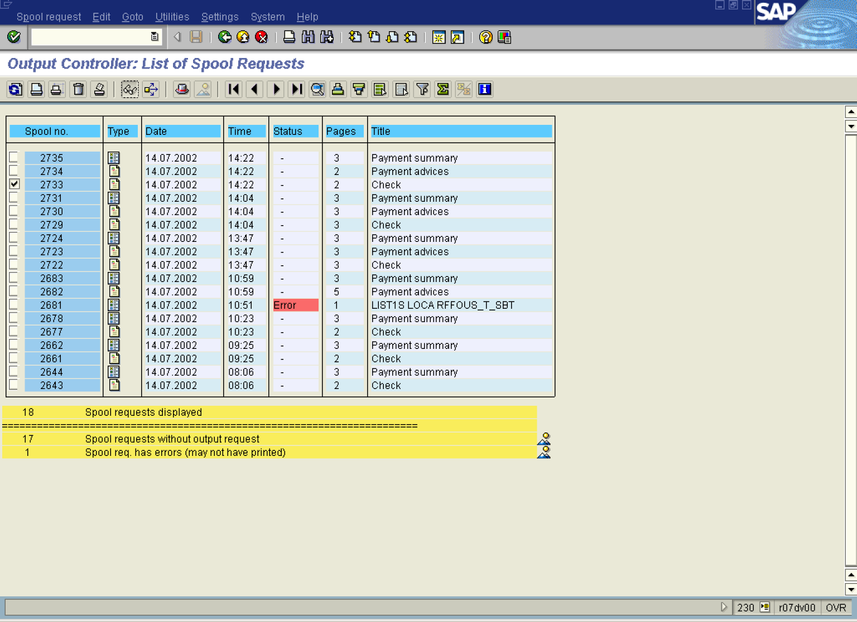

20. Mark the required print job, e.g. click 2733 checkbox .

21. You can display your print job before printing it. Click Display Button .

Print Preview for LOCA Page 00001 of 00002

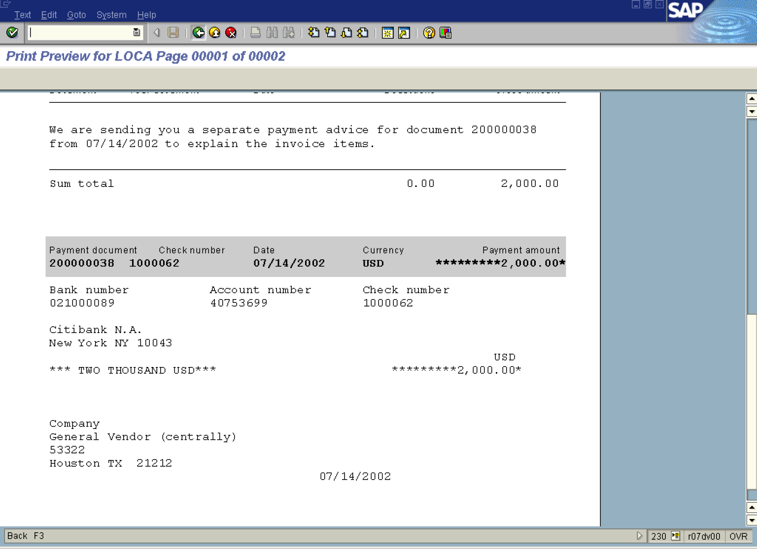

22. Click Back .

23. In the same way you can display other print jobs.

24. Now you can print the checks. Make sure that the 2733 checkbox is selected and press Print Directly icon.

